**Scenario: Launch Automation_Practice_Url**

**Step: Launch "Automation_Practice_Url" WebPage - PASS**

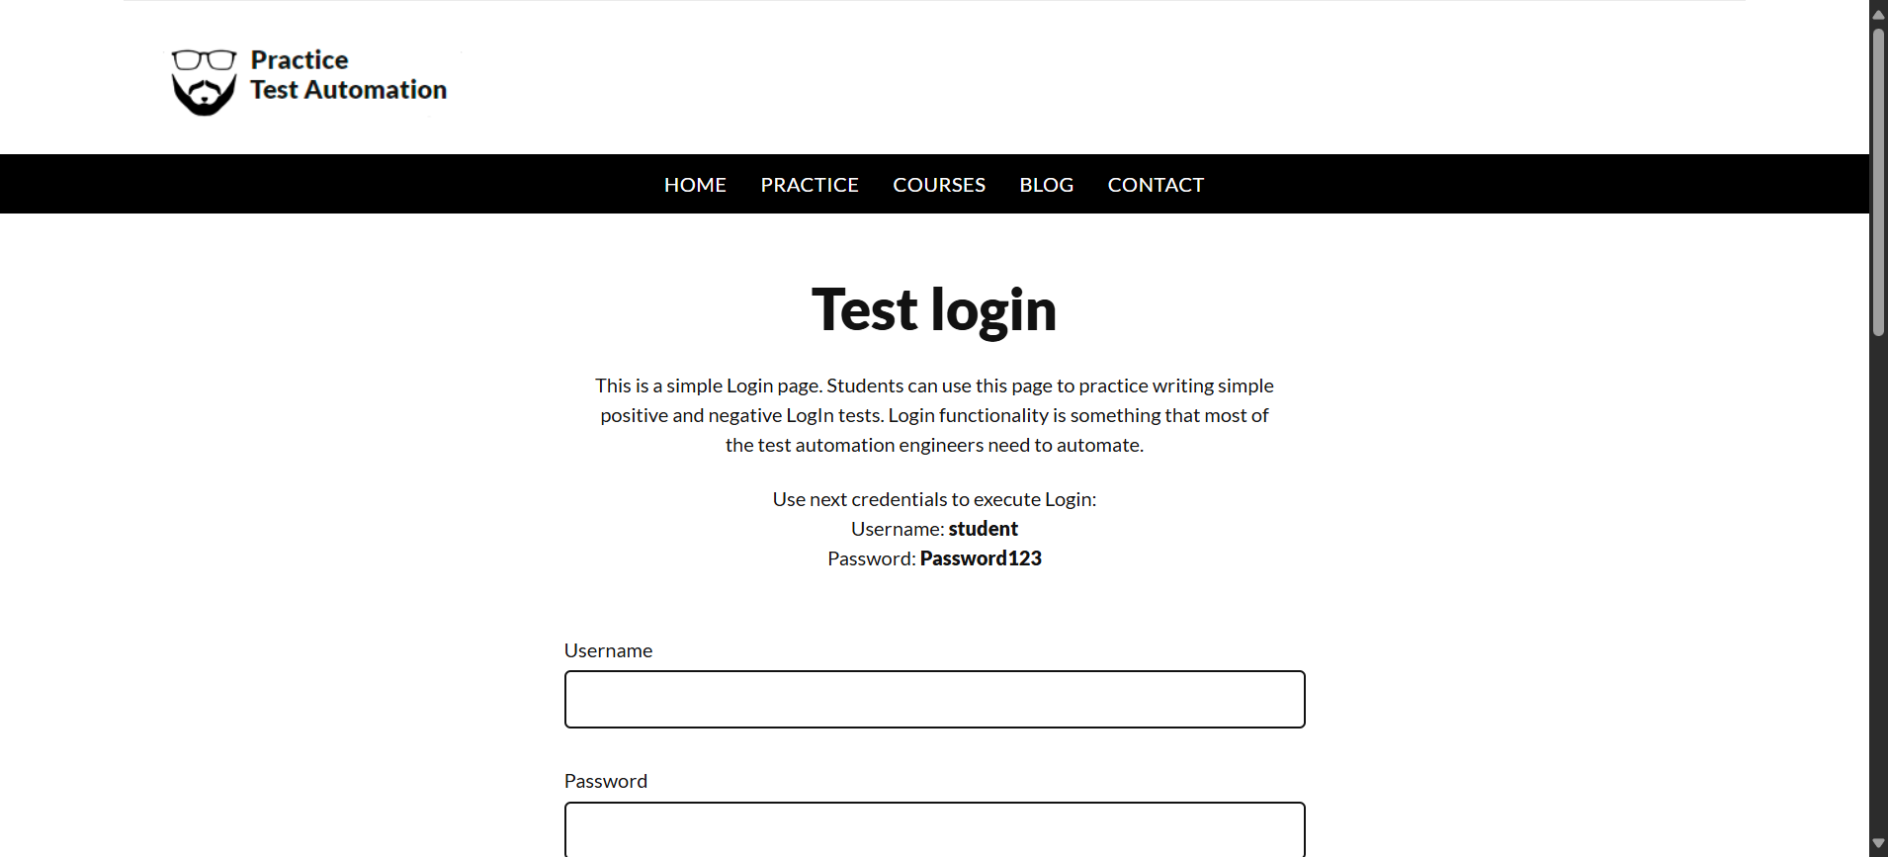

**Step: Enter UserName "username" into "Username" textbox at "LoginPage" page - PASS**

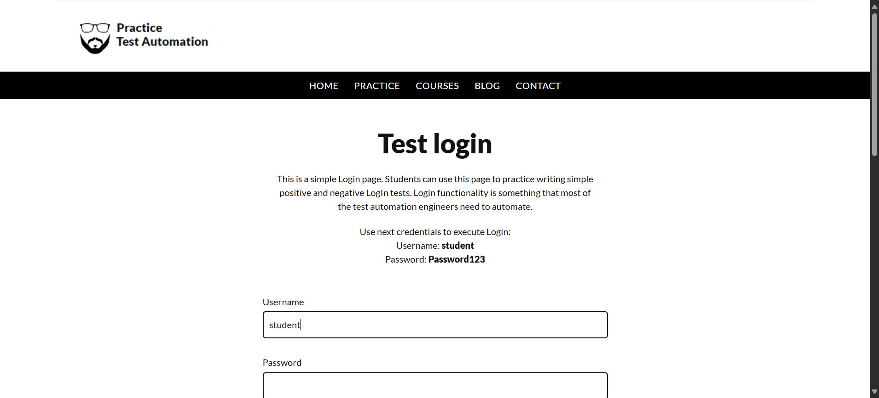

**Step: Enter Password "password" into "Password" textbox at "LoginPage" page - PASS**

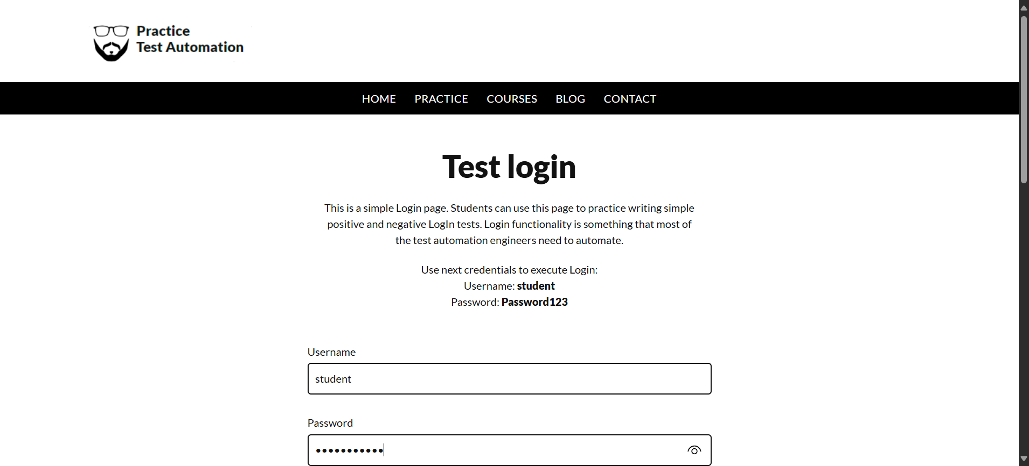

**Step: And the user waits for the "login_button" element to be "CLICKABLE" on the"LoginPage"page - PASS**

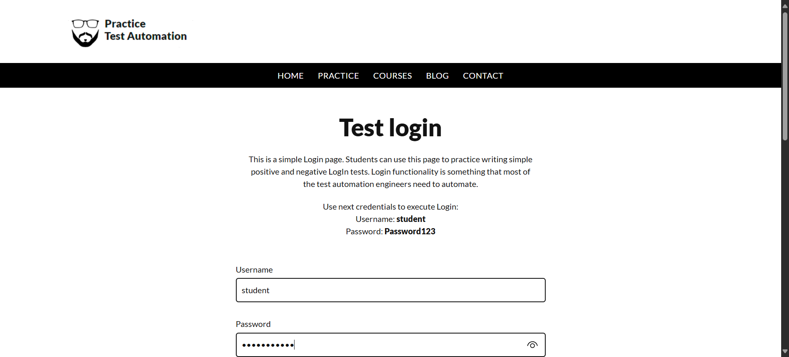

**Step: User click the "login_button" element at "LoginPage" page - PASS**

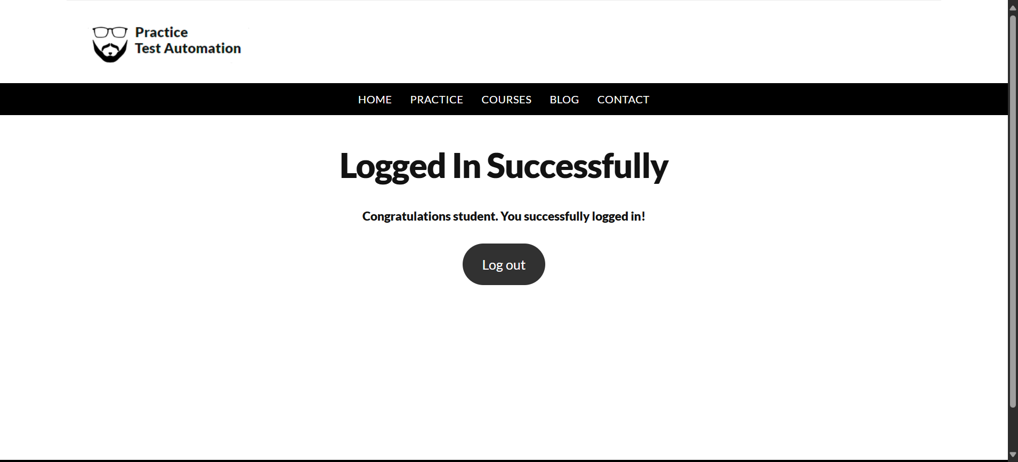

**Execution Summary:  
Total Steps: 5  
Passed: 5  
Failed: 0**

**Scenario: Launch Automation_Practice_Url123**

**Step: Launch "rahulshettyacademy" WebPage - PASS**

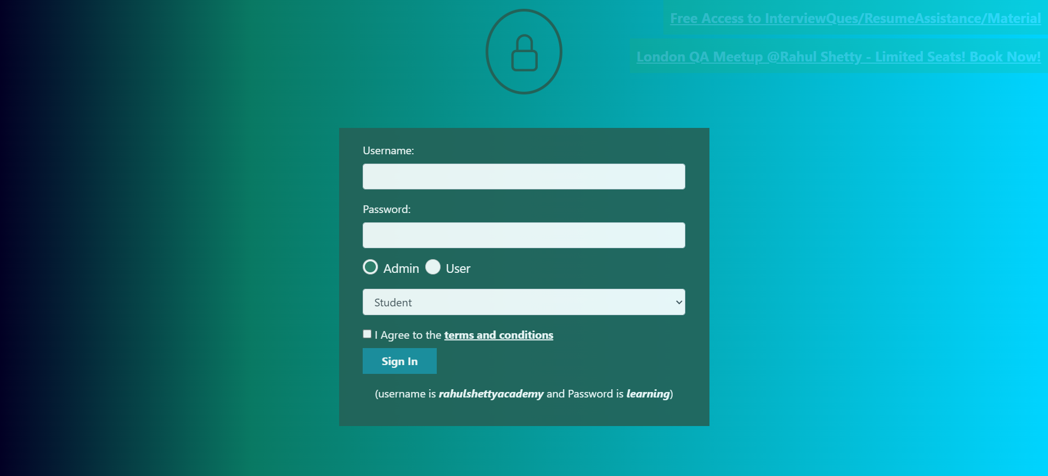

**Step: Enter UserName "rahul_username" into "r_username" textbox at "LoginPage" page - PASS**

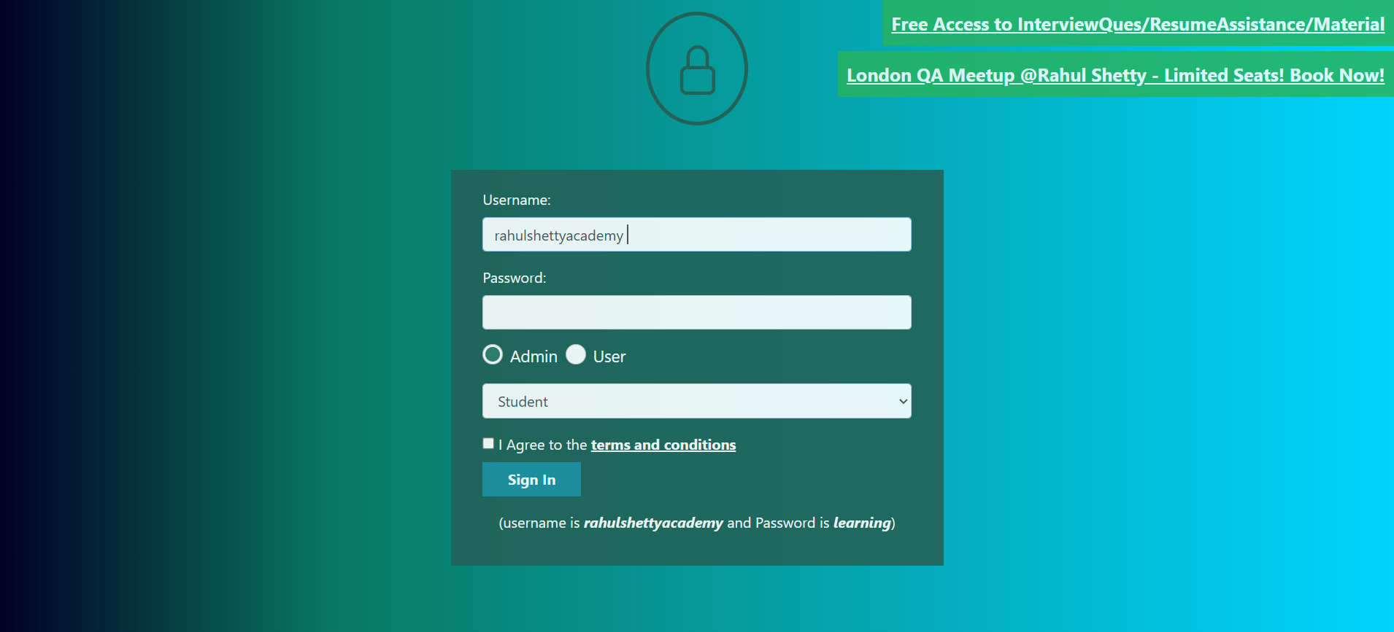

**Step: Enter Password "rahul_pass" into "r_password" textbox at "LoginPage" page - PASS**

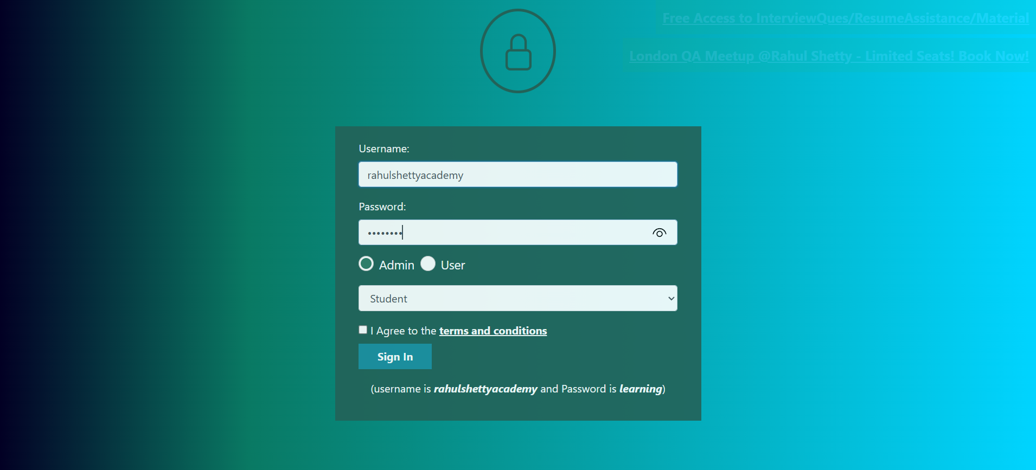

**Step: And the user waits for the "r_sigin" element to be "VISIBLE" on the"LoginPage"page - PASS**

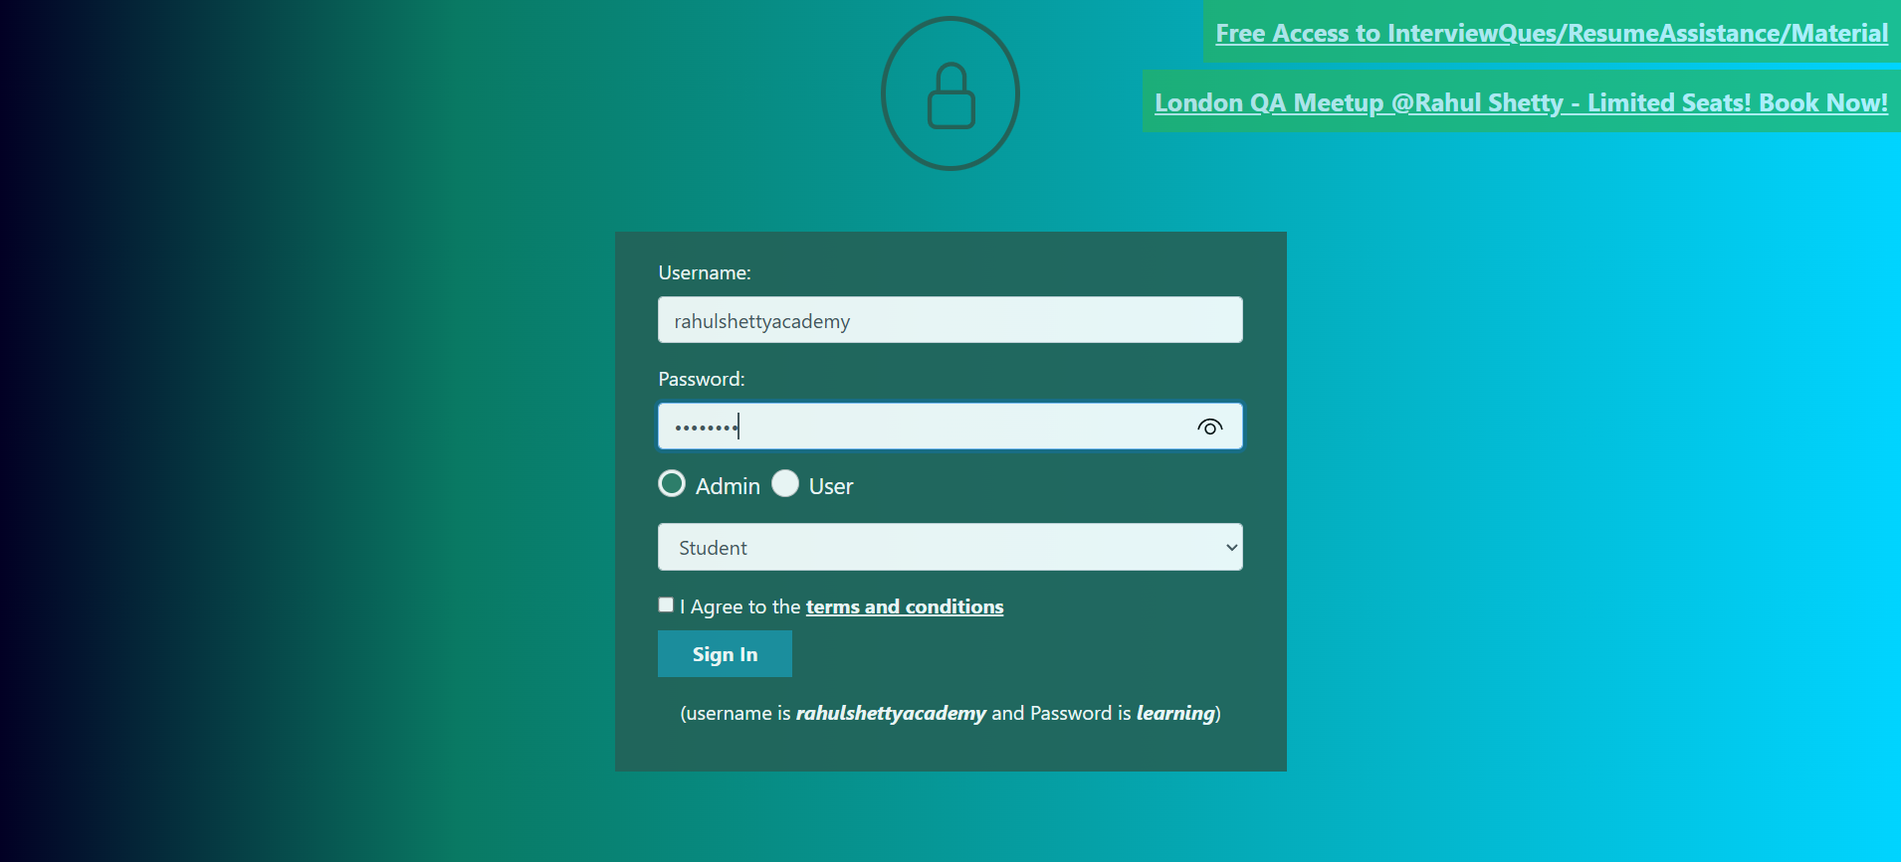

**Step: User click the "r_sigin" element at "LoginPage" page - PASS**

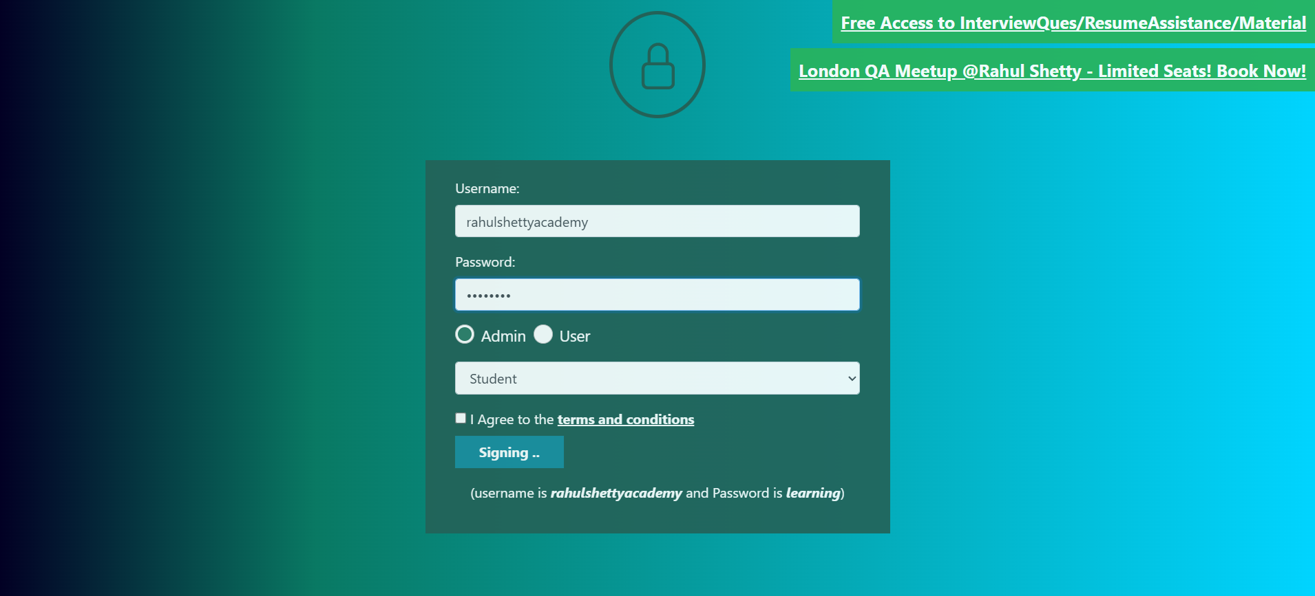

**Execution Summary:  
Total Steps: 10  
Passed: 10  
Failed: 0**